Sales Tax on Gift card sales
- Open D365 10.0+ supported version, USRT company.
- Set up Gift card in Commerce parameters:
Search for Commerce parameters/Tab Posting/section Gift card:
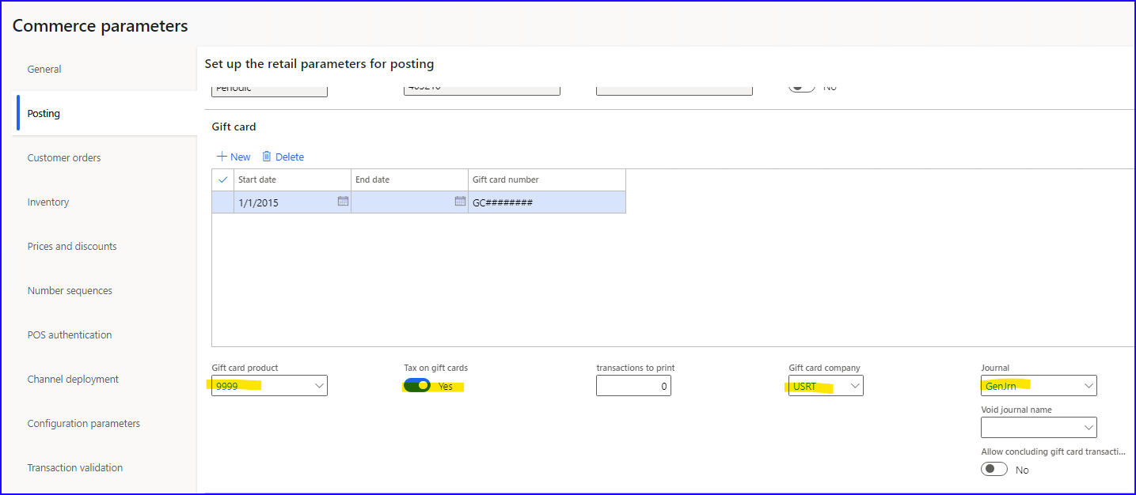
- Gift card product= 9999
- Tax on gift cards= YES
- Gift card company= USRT
- Journal= GenJrn

- Set up Item sales tax group on Gift card item:
Search for Released products by category/find Gift card item 9999/Edit/Tab Sell/section Taxation:
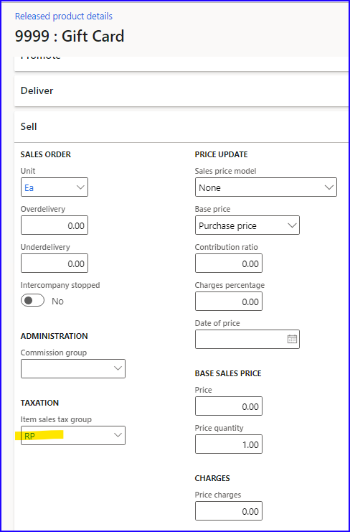
- Item sales tax group= RP

- Set up Price include sales tax on a store:
Search for All stores/select HOUSTON/Edit/section Sales tax:
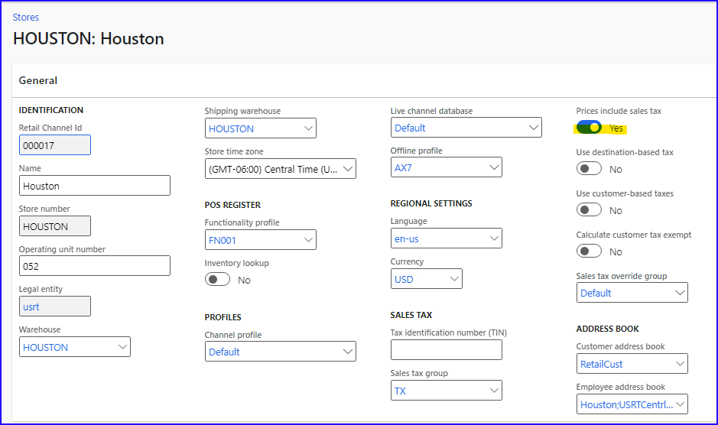
- Prices include sales tax= should be marked to YES

- Distribute changes to POS:
Search for Distribution schedule/select 9999 All jobs/Run now.

Search for Download sessions/Refresh/Check if the Status is Applied.

- Issue gift card in POS:
Open POS. Log in.
Current transaction/Enter customer 1001.
Actions/Gift cards/Issue gift card:
- Card number= 998877
- Amount= 500,00
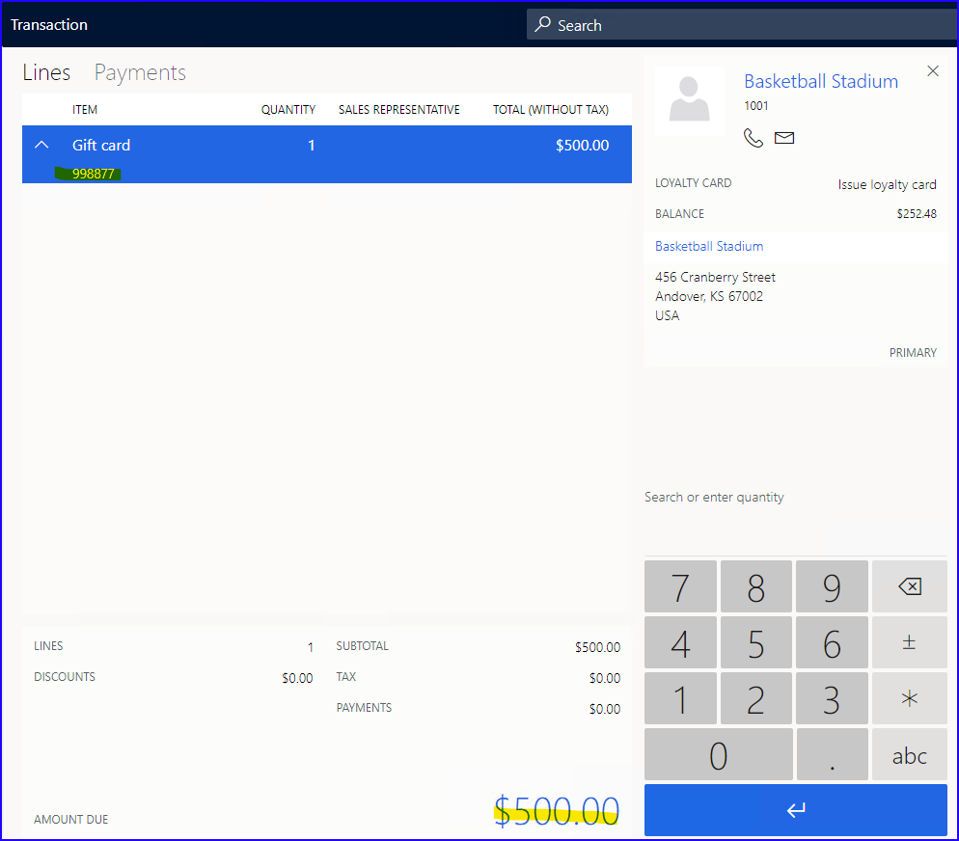
- Subtotal= 500,00
- Tax= 0,00
/Pay Cash.
/Close shift.

- Run P-job:
Search for Distribution Schedule/select the P-0001 job/Run now/OK.
- Validate store transactions:
Search for Validate store transactions/select Houston store/OK.
- Create Retail Statement:
Search for Statements/New/Transaction posting (Trickle-feed feature enabled)/select HOUSTON Store number/OK/Statement calculated:
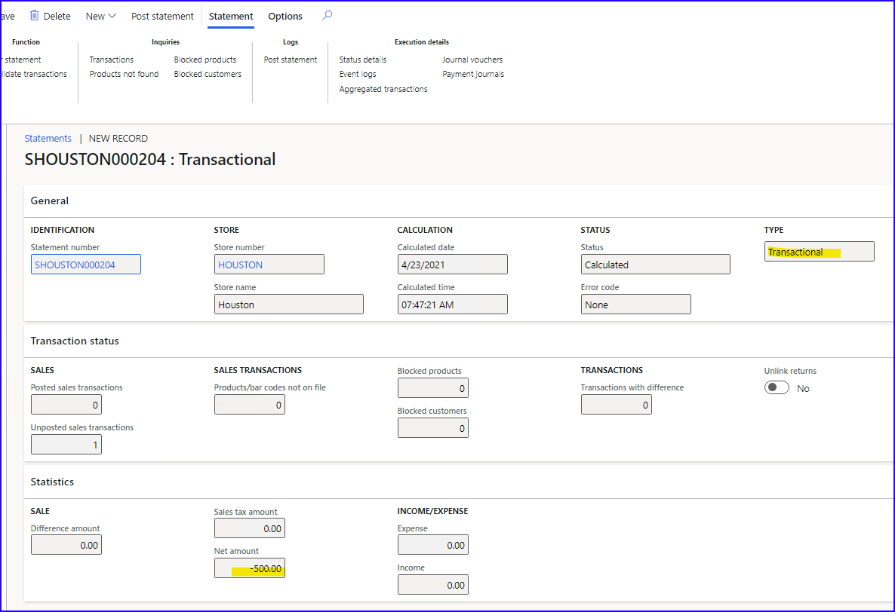
Transactions included:
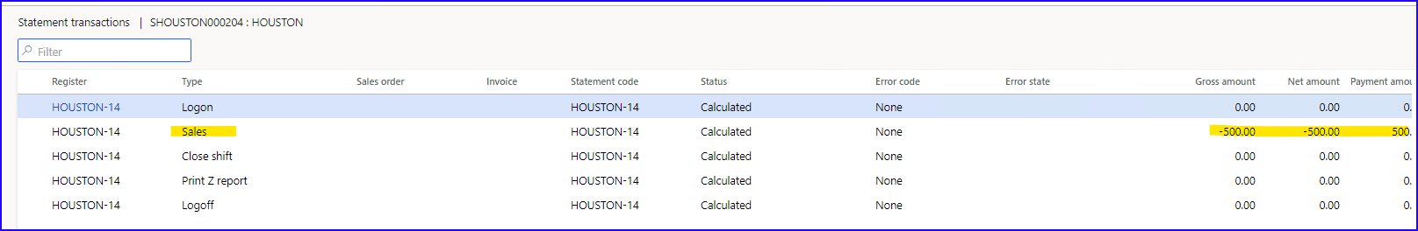
/Post statement.
- Check posted vouchers:
Search for Audit trial/sort by date/3 vouchers are posted:
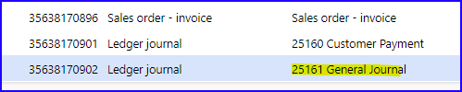
- Sales invoice voucher:
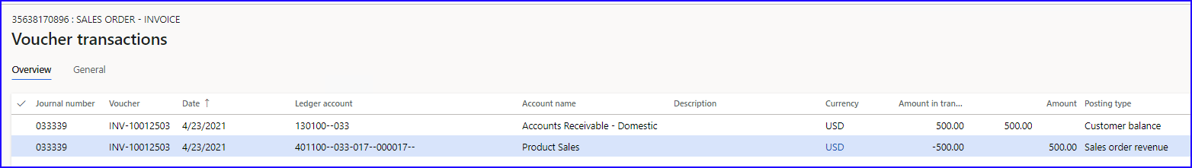
- Payment posted:
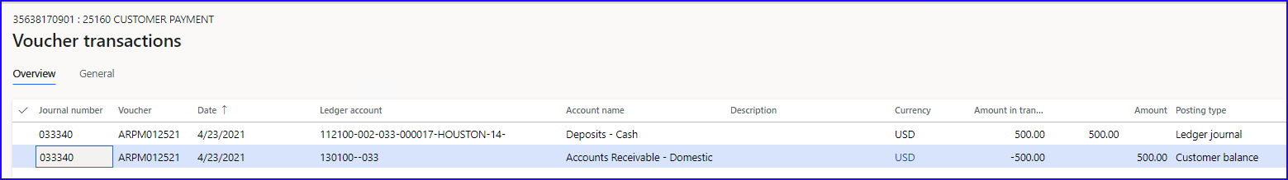
- Sales tax on issued gift card voucher:
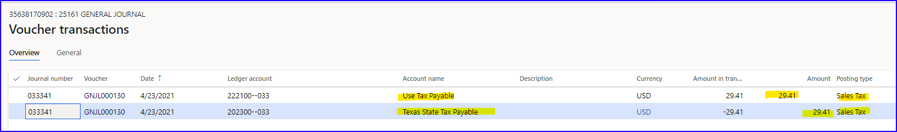
Posted two ledger transactions with Sales tax 6,25% as per setup in Gift card item:
- One with Sales tax direction= Use tax Debit
- Other with Sales tax direction= Sales tax payable Credit

- Sell an item in POS and pay with a Gift card:
Open POS. Log in.
Current transaction/Enter customer 1001.
Enter item 0113.
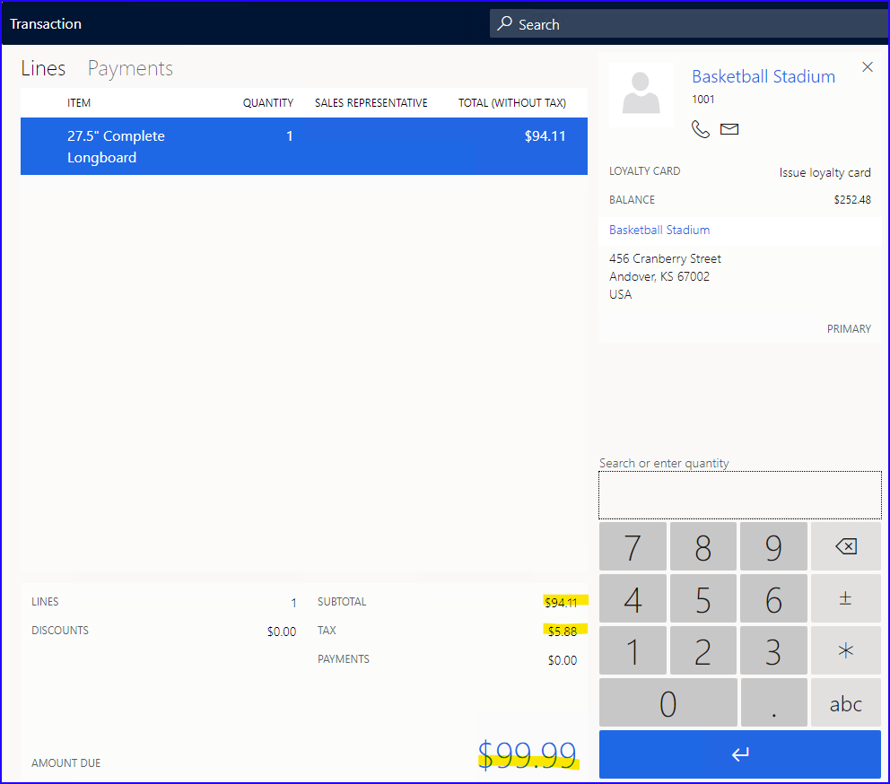
- Subtotal= 94,11
- Tax= 5,88
- Amount due= 99,99

Pay gift card/Add Gift card number 998877/Tender payment.
/Close Shift.

- Run P-job:
Search for Distribution Schedule/select the P-0001 job/Run now/OK.
- Validate store transactions:
Search for Validate store transactions/select Houston store/OK.
- Create Retail Statement:
Search for Statements/New/Transaction posting (Trickle-feed feature enabled)/select HOUSTON Store number/OK/Statement calculated:
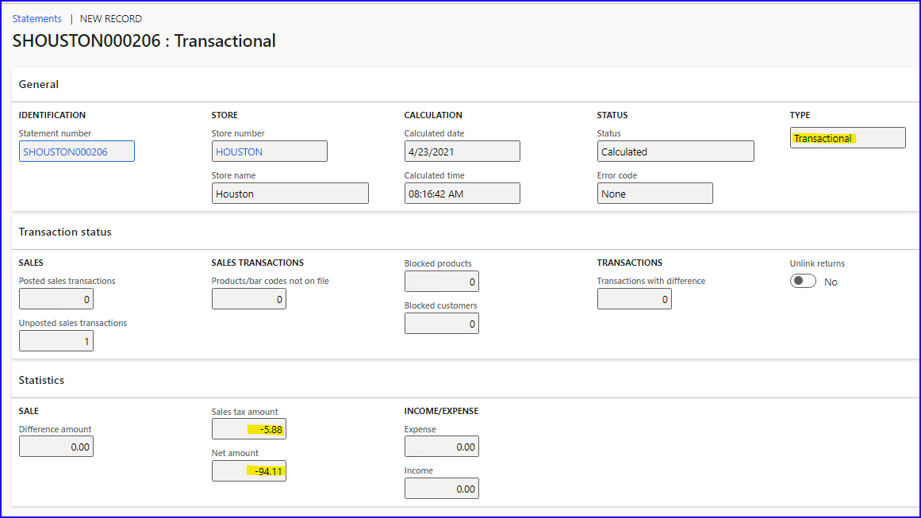
Transactions included:
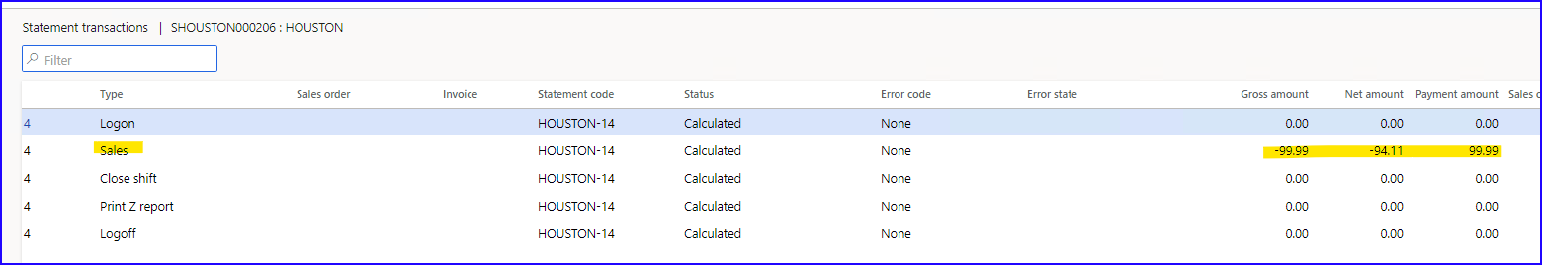

/Post statement.
- Check posted vouchers:
Search for Audit trial/sort by date/3 vouchers are posted:
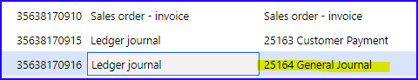
- Sales invoice voucher:
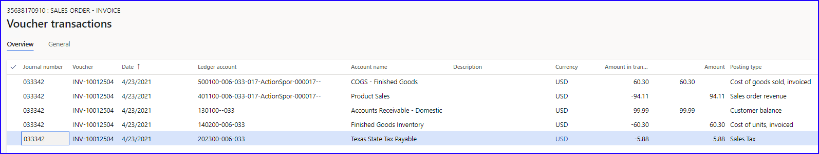
- Payment posted:
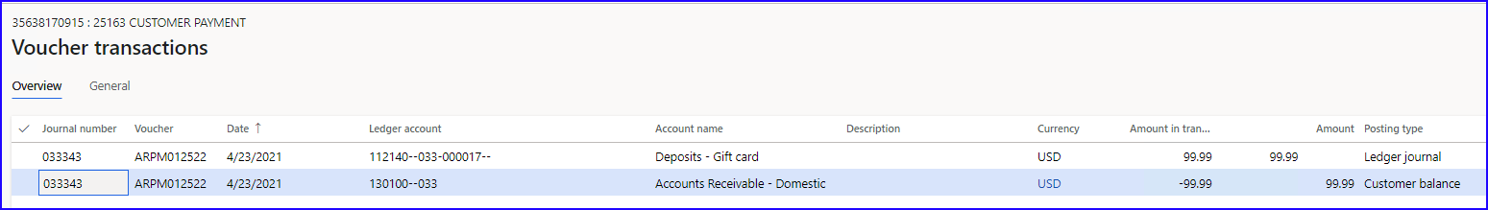
- Sales tax posted for payment with Gift card (reducing sales tax from initially posted sales tax for issued gift card):
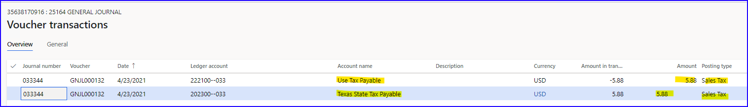
Posted two ledger transactions with Sales tax 6,25% as per setup in Gift card item:
- One with Sales tax direction= Use tax Credit
- Other with Sales tax direction= Sales tax payable Debit

