Destination-based Sales tax configuration for Online stores
- Set up ‘Sales tax codes’:
Search for ‘Sales tax codes’/New:
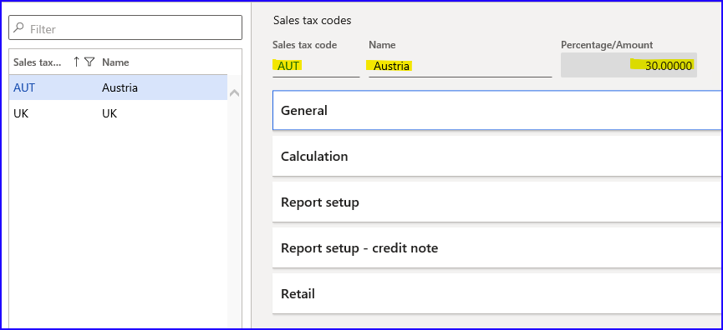
- Sales tax code= AUT e.g. for Austria
- Percentage/Amount= 30%
/New:
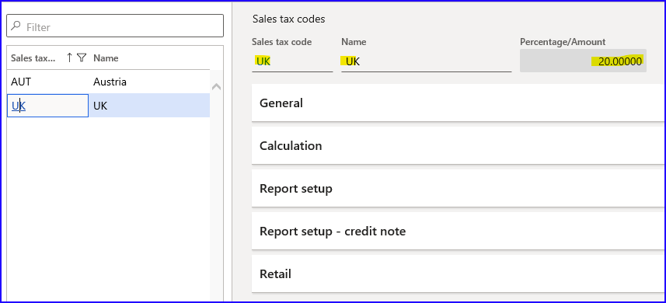
- Sales tax code= UK e.g. for United Kingdom
- Percentage/Amount= 20%

- Set up ‘Sales tax groups’:
Search for ‘Sales tax groups’/New:
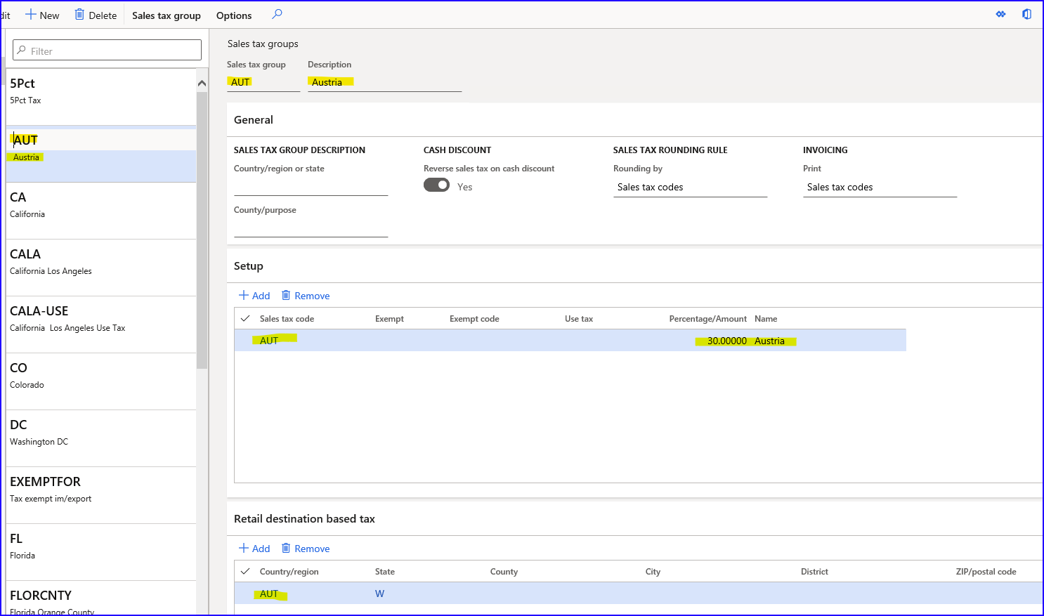
- Sales tax group= AUT, e.g. for Austria
- Sales tax code= AUT with 30%
- Tab Retail destination based tax – Country/region= AUT (important to add all countries/regions which need this sales tax group to be used in Online store)
/New:
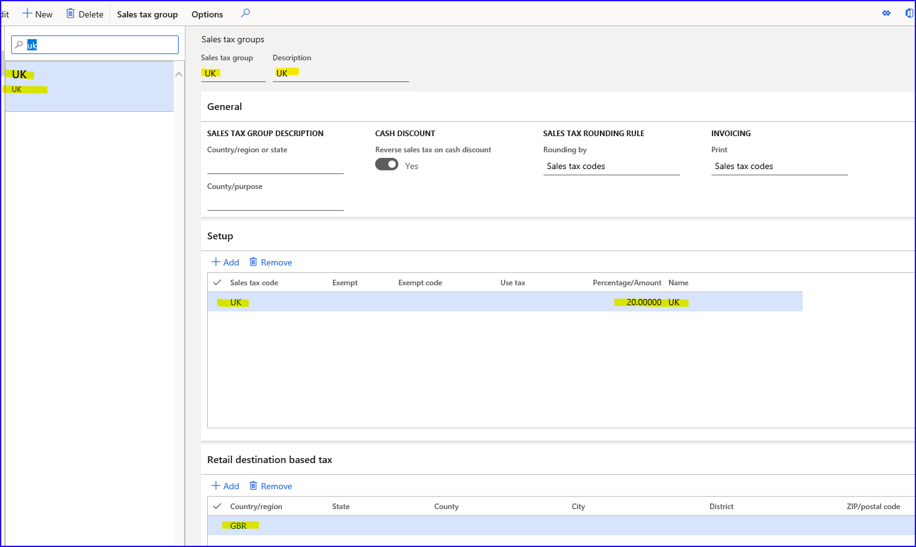
- Sales tax group= UK, e.g. for United Kingdom
- Sales tax code= UK with 20%
- Tab Retail destination based tax – Country/region= GBR

- Set up Item sales tax group:
Search for ‘Item sales tax groups’/New:
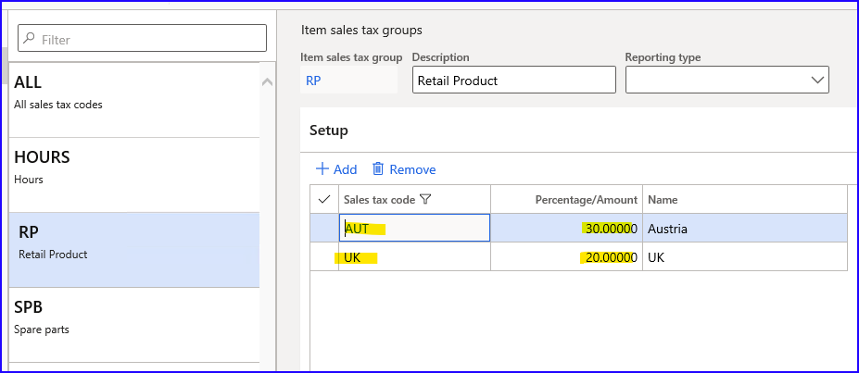
- Item sales tax group= RP (it should be general group for the products, better not to use only for one percentage. This group in combination with Sales tax code and Sales tax group will give a necessary percentage)
- Tab Setup/Add/Sales tax code= add AUT and UK

- Set up Item sales tax group on a product:
Search for ‘Released products by category’/open item 4205/Tab Sell:
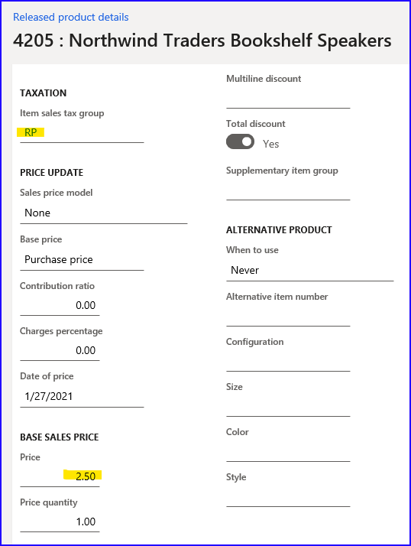
- Item sales tax group= RP
- Base sales price= 2,50

- Create delivery addresses for customer account and add Sales tax group accordingly:
Search for ‘All customers’/open customer account 100002 Default Online Customer/Tab Addresses/Add:
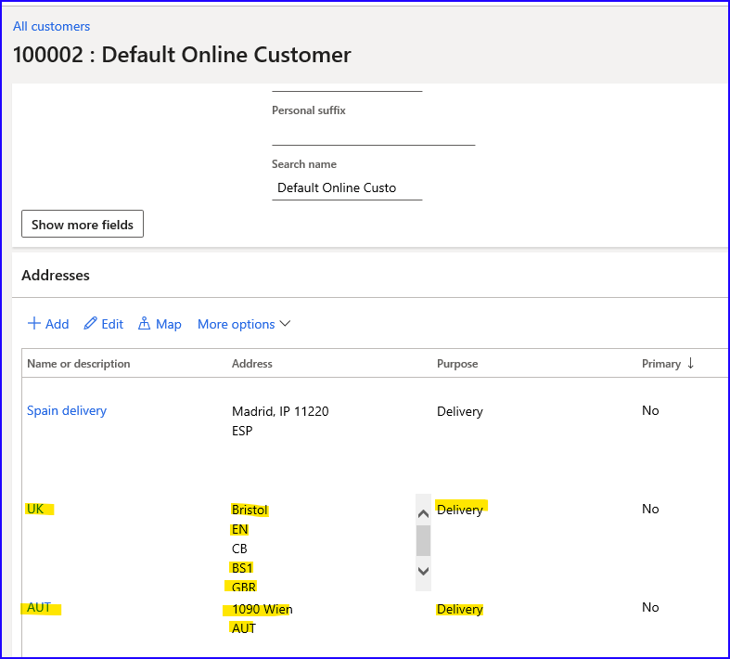
UK delivery address:
- Name= UK
- Purpose= Delivery
- Country/region= GBR
- ZIP/Postal code= BS1
- City= Bristol
- Sate= EN (England)
- County= CB
AUT delivery address:
- Name= AUT
- Purpose= Delivery
- Country/region= AUT
- ZIP/Postal code= 1090
- City= Wien
Save them.
Select UK address/More options/Advanced:
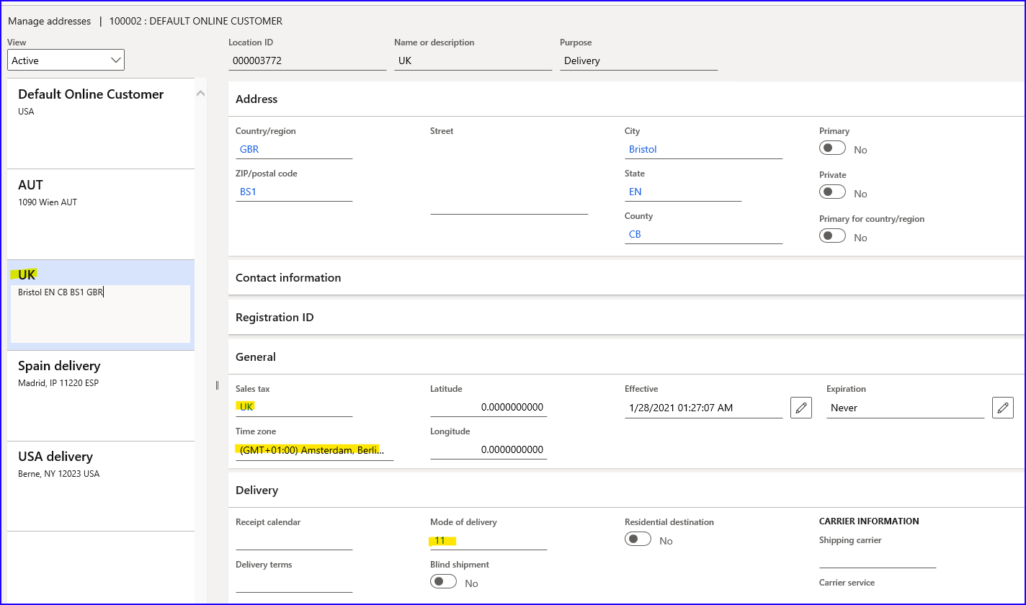
- Sales tax= UK (Sales tax group)
You may select there also Tome zone or Mode of delivery if necessary.
Select AUT address/More options/Advanced:
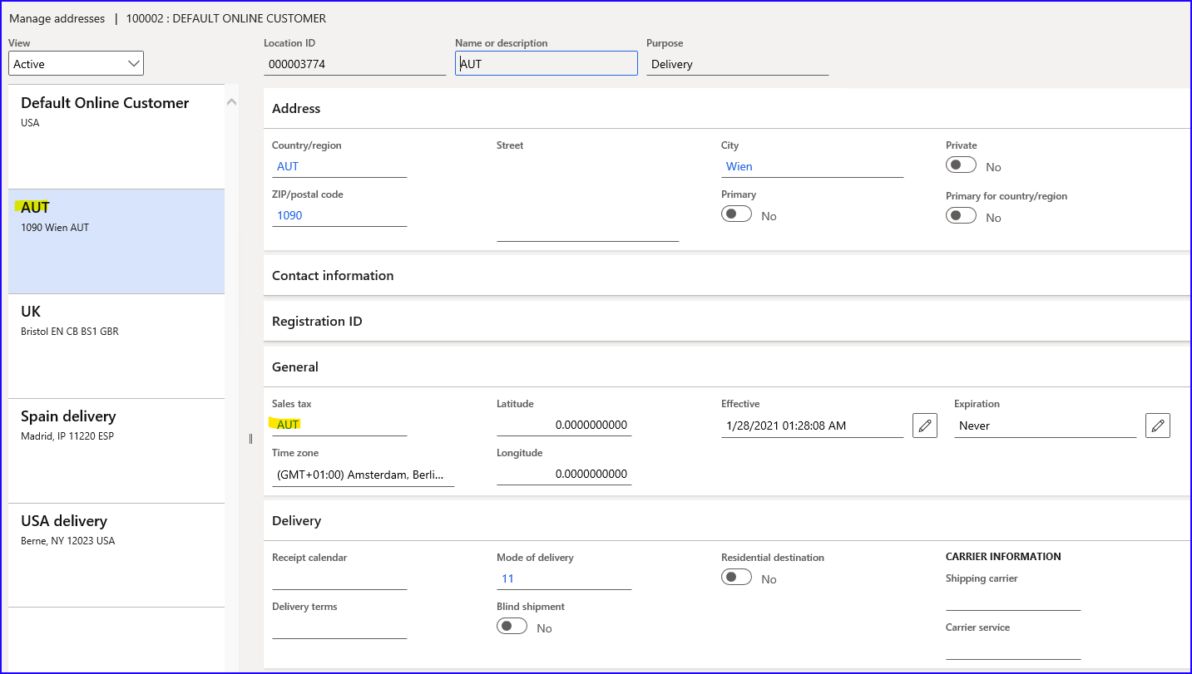
- Sales tax= AUT (Sales tax group)

- Set up your Online store:
Search for ‘Online stores’/open Contoso Online Store:
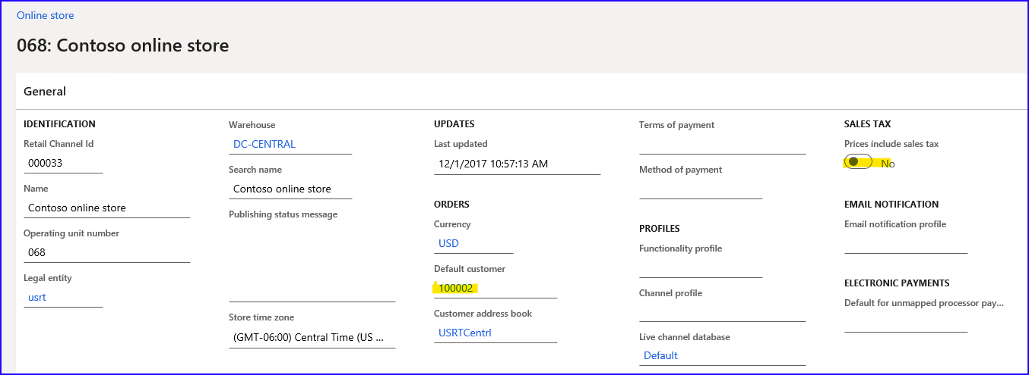
- Prices include sales tax= NO
If your prices are sales tax included, switch this parameter to YES.
- Add Modes of delivery to Online store:
From Online store/Tab Set up/Modes of delivery/select e.g. 11 Ground/be sure there are these data added:
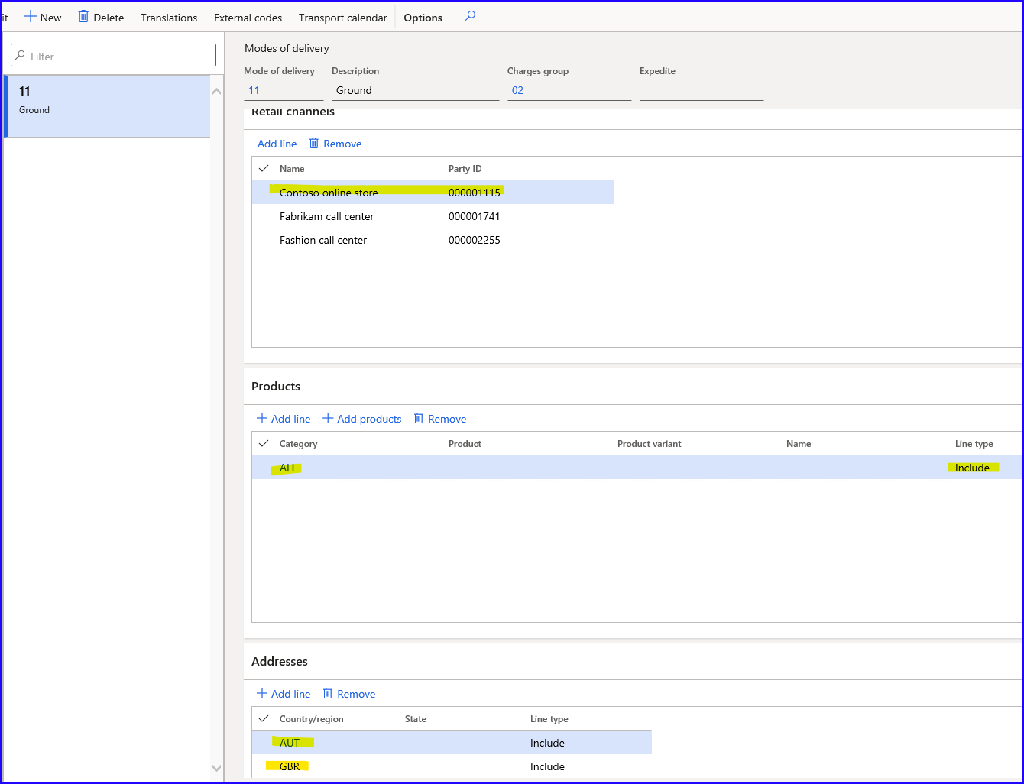
- Tab Retail channels/Add line/Contoso online store
- Tab Products/Add line/Category ALL/Line type=Include
- Tab Addresses/Add line/Country/region add AUT and GBR/Line type= Include
Search for ‘Process delivery modes’/run it.
- Run 9999 job:
Search for ‘Distribution schedule’/Select 9999 job/Run now.
Make sure that the status of all jobs is ‘Applied’ in Download sessions.

- Open Online store and sell the product:
Add item 4205 to the cart. Price is 2,50 before tax.
/Checkout/Checkout as a guest/Delivery preference select Ship items/enter Shipping address for Austria the same as it was created as delivery address on a customer account in HQ.
/Get shipping options/select Ground/Next step/add Credit card data/Billing address/Same as shipping address add a check mark/Next step/review and confirm:
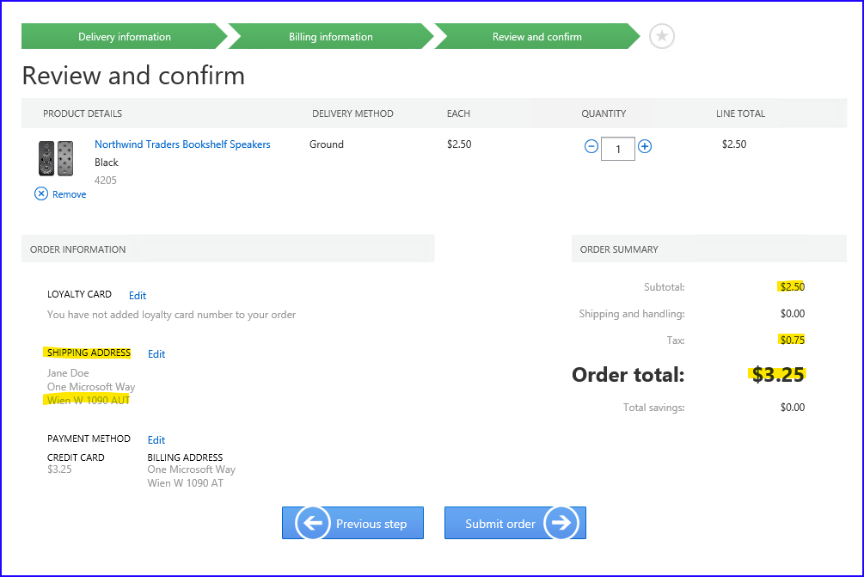
- Subtotal= 2,50
- Tax= 0,75 (30%)
- Order total= 3,25
If we edit Shipping address for the same item, e.g. to UK shipping address, tax is calculated 20%:
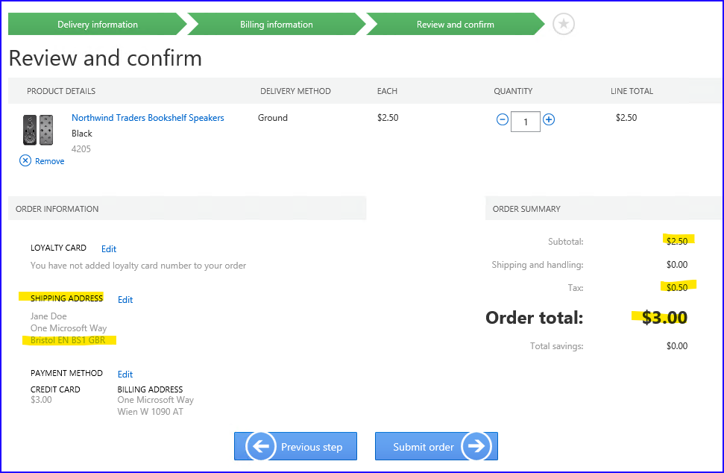
- Subtotal= 2,50
- Tax= 0,50 (20%)
- Order total= 3,00
Conclusion:
The system is verifying what Item sales tax group from the product is set in combination with Sales tax code and the same Sales tax code is set on a Sales tax group for some delivery address – such percentage of sales tax will be used on store transaction.

