- Open 10.0.13 or any later version, USRT company.
- Enable Feature:
Go to Feature management/Tab All/find Enable tax exemption for the 'price includes sales tax' scenario/Enable now.
Restart D365.
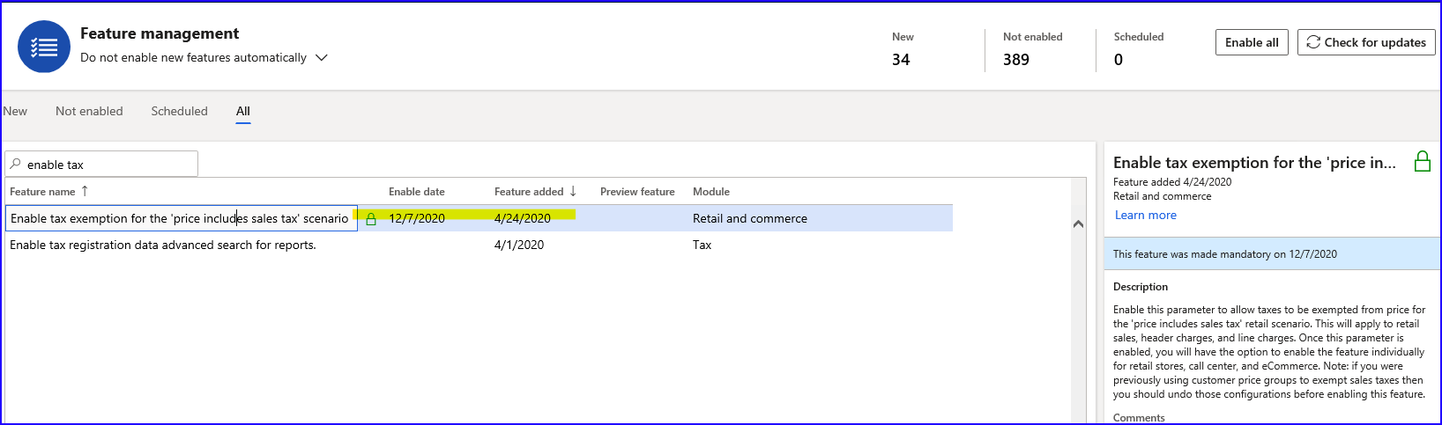
- Store setup:
Search for ‘All stores’/select Houston/Edit:
- Sales tax group= TX
- Prices include sales tax= YES
- Calculate price inclusive tax exempt= YES (Do not mix with ‘Calculate customer tax exempt’ parameter – it is related to ‘Prices include sales tax=NO’ scenarios)
- Sales tax override group= Default
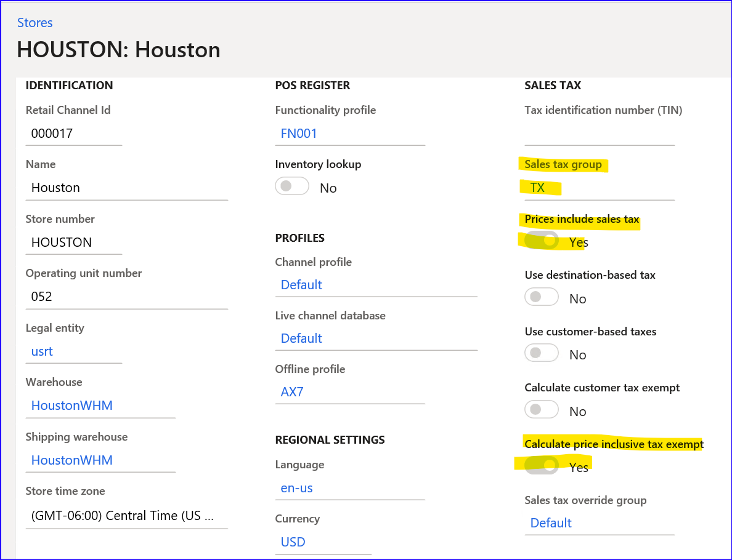
- Create new Sales tax group:
Search for Sales tax groups/New:
- Sales tax group= EX
Tab Setup/Add:
- Sales tax code= RP_TXST
- Exempt= YES
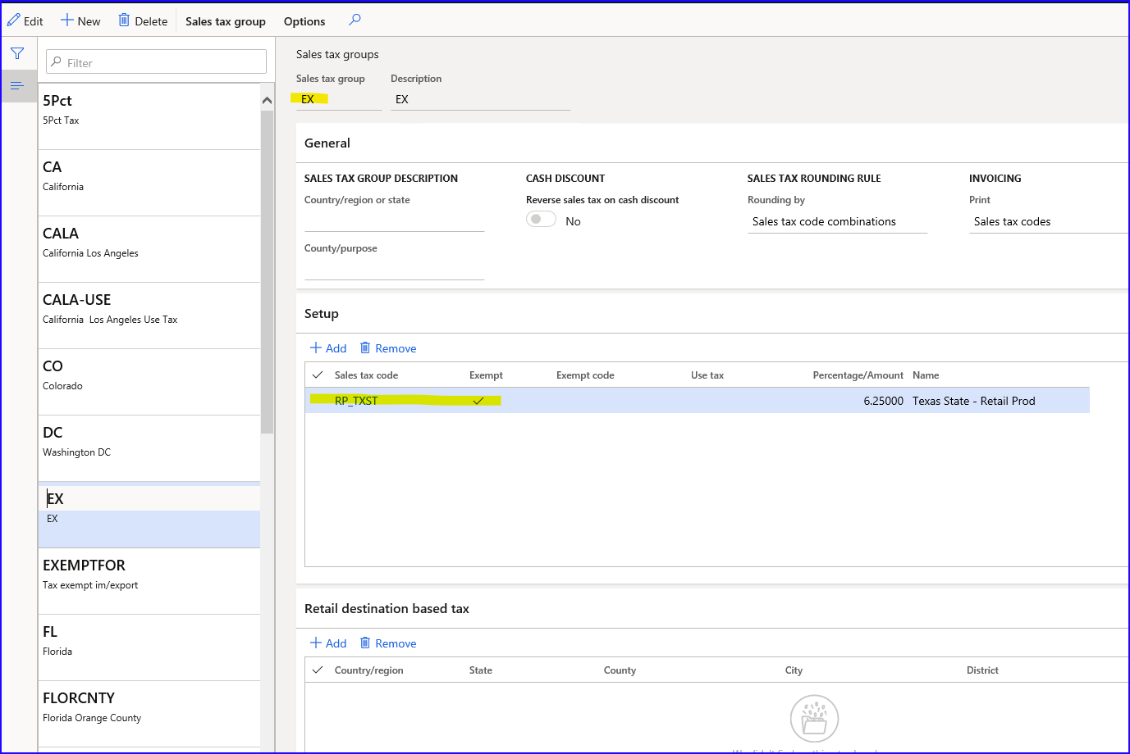
- Sales tax overrides setup:
Search for ‘Sales tax overrides’/New:
- Sales tax override= EX
Tab Override:
- Type= Sales tax group
- From= Specified tax group
- To= Specified tax group
- From tax group= TX
- To tax group= EX
- Override by= Transaction
- Status= Enable
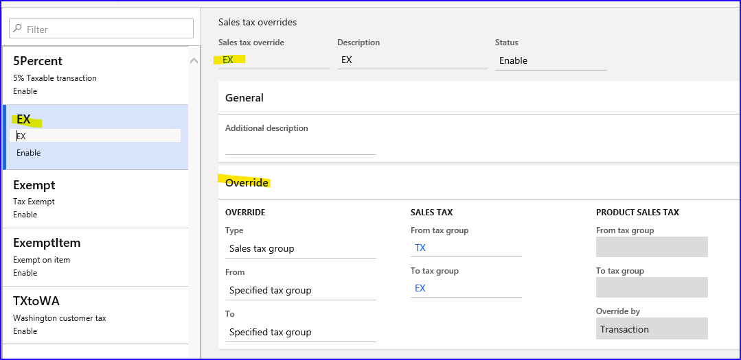
- Sales tax override groups setup:
Search for ‘Sales tax override groups’/Edit/Add:
- Sales tax override= EX
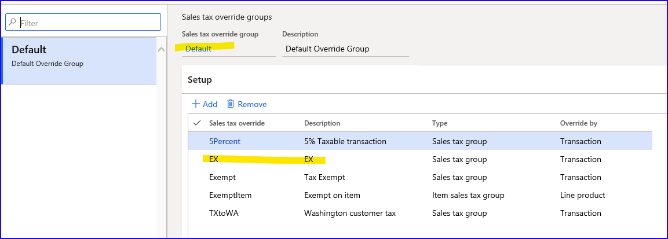
- Run 9999 job. Be sure all jobs are applied.
- Restart IIS as Tax details for the channel might be cached. Then close the point of sale application and relaunch it to to observe the changes after they have synchronized to the channel database.
- Sell item in POS:
Open POS, log in.
Go to Current transaction.
Add item 91050. See Subtotal 70,59, sales tax calculated 4,41, Total amount 75,00:
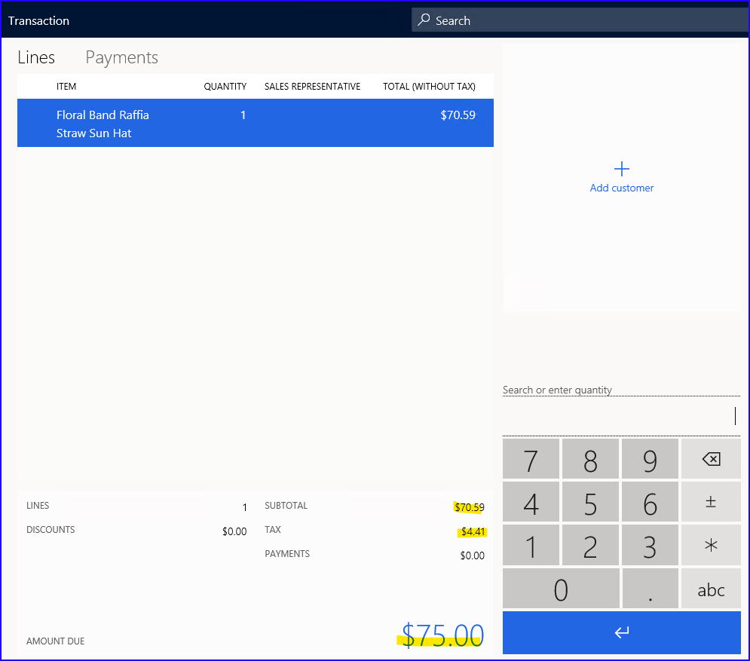
Click on ‘Tax overrides’/Override transaction tax/select EX/enter tax ID 1234/OK:
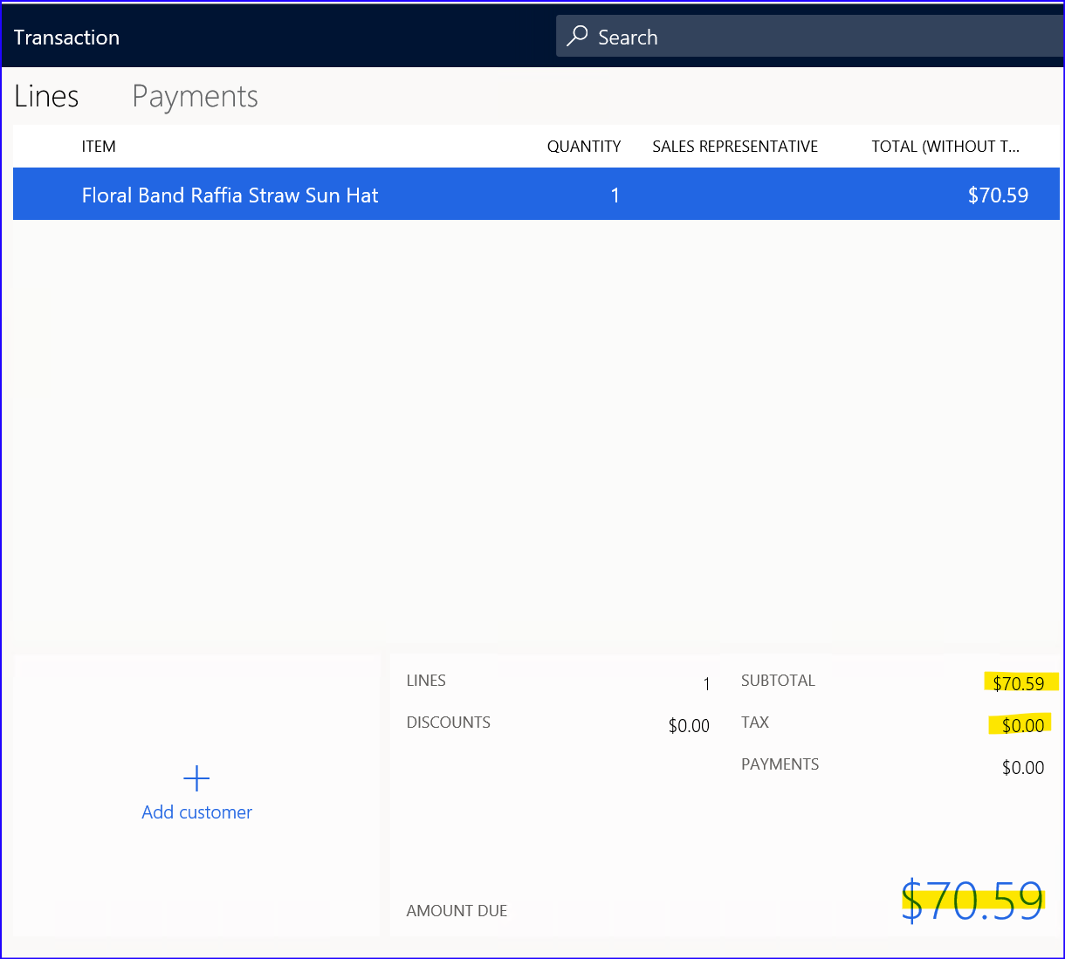
Actual results:
Sales tax amount 4,41 is deducted from the price tax included and now we have amount the same as it was before tax – 70,49:
- Subtotal= 70,59
- Tax= 0,00
- Amount due= 70,59

