Dynamics 365 Intelligent Order Management Implementation Guide

Date | Author | Change(s)
1/27/2023 | Ray Bennett <bennettray@microsoft.com> | Initial Draft
1/30/2023 | Ray Bennett <bennettray@microsoft.com> | Added Fulfillment Guidance
1/31/2023 | Ray Bennett <bennettray@microsoft.com> | Added Development Flows, Support, Additional guidance on fulfillment

Overview
This guide is used as a reference for implementing Dynamics 365 Intelligent Order Management. It will cover the key decision points used to determine what needs to be installed and configured as well as guidance on how to configure each of those areas. This guide is not intended to document the experience, but to give references where you can find additional information.

Key Decisions
The following matrix will help with determining what functionality will be needed from Intelligent Order Management. For each feature, document if you will be using them.

Feature | Will be used?
Dynamics 365 Finance and Operations (dual-write) | Will Finance and Operations be used. Is the Finance and Operations system already in place?
Inventory Visibility | Use Inventory Visibility with or without Finance and Operations
Fulfillment and Return Optimization | Use the Fulfillment Optimization Engine
Returns | Use the Returns experience if your Ecommerce site supports it, such as BigCommerce
Carting | Use the Carting experience if your Ecommerce site supports it. Currently this is only available as a custom integration.
Define your Data Migration Strategy | One or a mix of the 3 options

Additionally, document which out-of-box and custom providers will be used.
Out of Box | Custom
Fedex/UPS/etc… Provider catalog | Microsoft Learn | Any custom providers you have identified

For the purposes of licensing, how many order lines/month will need to be handled.
Order Lines/month

Checklist
You can use the following checklist to help guide your steps through the implementation
Feature | Step | Optional | Completed
Setup | Acquire License | No
Setup | Create Environment (LCS) | Yes – See Below
Setup | Create Environment (Standalone) | Yes – See Above
Setup | Install Intelligent Order Management | No
Setup | Configure Initial Connections and Activate | No
Configuration | Enable Features | Yes
Configuration | Setup Email Templates | Yes
Configuration | Finance and Operations | Yes
Configuration | Setup Dual Write for Finance and Operations | Yes
Configuration | Inventory Visibility | Yes
Configuration | Inventory Visibility Measures | Yes
Configuration | Inventory Visibility Dashboards | Yes
Configuration | Inventory Visibility Allocation | Yes
Configuration | Available to Promise | Yes
Configuration | Backorder/Preorder Capabilities | Yes
Configuration | Fulfillment Optimization | Yes
Data Migration | Bring in Master Data | Yes
Data Migration | Mapping | Yes
Supply Chain Management | Procurement (Purchase Orders) | Yes
Supply Chain Management | Transfer Orders | Yes
Providers | Setup your provider(s) | No
Orchestration | Creating Policies/Rules | Yes
Orchestration | Creating an Orchestration Journey | No
Development | Create Custom Providers | Yes
ALM | Develop an Application Lifecycle Management Strategy | No

Basic Concepts
Understanding the different portals Working with the admin portals and admin centers - Power Platform | Microsoft Learn
Managing Users Create users - Power Platform | Microsoft Learn
For the purpose of this document, there are 2 sections of the application that may be referred to. If the Settings Area is referenced, you can navigate to that area in the bottom left of the Intelligent Order Management and using the selector to switch the Area.
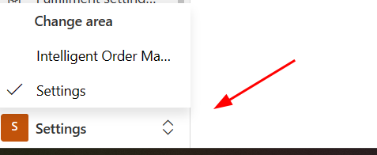

Acquiring Dynamics 365 Intelligent Order Management
There are 3 primary ways of getting/testing Intelligent Order Management. Hosted Trial, Trial and Paid.

Hosted Trial
The trial experience is a 30 day trial that includes demo data, demo providers and allows you to get a look at the product. It is not intended to be used for a proof of concept or long term projects. This trial is hosted in the Microsoft Cloud.
For more information and to get started see Intelligent Order Management | Microsoft Dynamics 365

Trial
The Trial is available in your own tenant. Follow the instructions for installing an environment, and when selecting the environment type, select Trial. This can be used with a Trial license which allows for a 30 day period which can be extended.

Paid
Paid versions of Intelligent Order Management allow the product to be used for longer than 60 days. This is the preferred method for implementation and longer proof of concepts. For Microsoft Certified Partners, there is a Partner license available that enables a paid environment experience. Following this guide, simply select the correct license, and setup your environment as needed.

Licensing
The following licenses are available for Intelligent Order Management
- Trial – this allows for a 30 day trial able to be extended one time by 30 days for a total of 60 days. See Get trial licenses for Intelligent Order Management | Microsoft Learn for more information.
- Partner – long term license available to Microsoft Certified Partners.
- Paid
  - 1000 order lines/month available as part of Microsoft Supply Chain Management
  - $300 per 1000 order lines/month as a standalone product. Discounts may be available for higher volume usage. Work with your Account Executive for acquiring this license

Installation
Once you have acquired licenses for Intelligent Order Management, you will need to determine what method you will use to install the product.

Using Intelligent Order Management with Finance and Operations (dual-write)
If you are using Finance and Operations it is preferred to create the environment by using Lifecycle Services and linking your Power Platform environment to Finance and Operations from there.
If you do not have a Finance and Operations deployment, see Enable the Microsoft Power Platform integration - Finance & Operations | Dynamics 365 | Microsoft Learn
If you already have a Finance and Operations deployment, but have not enabled Power Platform see Dual-write setup from Lifecycle Services - Finance & Operations | Dynamics 365 | Microsoft Learn
If you already have Finance and Operations and Power Platform w/ Dataverse see Enable the Microsoft Power Platform integration - Finance & Operations | Dynamics 365 | Microsoft Learn

Intelligent Order Management Standalone (no dual-write)
In order to install Intelligent Order Management as a standalone application, follow the guide at Install Dynamics 365 Intelligent Order Management | Microsoft Learn

Configuration

System Activation
After installation, it is required to activate the system. You will configure the initial connections to Power Platform and Dataverse here. It is recommended that a service account be used to configure these connections.
During activation, Intelligent Order Management will create the backend power automate flows and turn them on. These flows are required for the system and providers to run.
Follow the guide here to activate the initial connections in the system Set up an environment | Microsoft Learn

Enable Features
There are some additional features that are enabled or disabled by default by navigating to the Settings Area > General Settings. You should review these and decide if they are applicable to your system or not.
At this time you might want to enable Bing Maps for your environment. This is required for some functionality such as fulfillment with distance determination. Enable Bing Maps for your environment | Microsoft Learn
Now is also a good time to determine if you want to use the Timeline feature to track history on entities Enable timeline capabilities | Microsoft Learn
You may also want to enable Alerts. Currently there is no documentation for this as it is in Private Preview.

Email Functionality and Templates
Setup any email templates that your system may need by following these instructions Email capabilities in Dynamics 365 Intelligent Order Management | Microsoft Learn

Finance and Operations
If you are integrating with Finance and Operations, you will need to enable the provider Set up the Dynamics 365 Finance + Operations provider | Microsoft Learn
You will need to configure dual write using the above article to enable data to be written to and from Intelligent Order Management Guidance for dual-write setup - Finance & Operations | Dynamics 365 | Microsoft Learn

Inventory Visibility
If you are using Inventory Visibility, you may need to install additional components, and then setup your inventory measurements.
If you are using Finance and Operations, make sure to install the add-in Install the Inventory Visibility Add-in - Supply Chain Management | Dynamics 365 | Microsoft Learn
Once you are ready to go, setup your measurements as defined in Set up Inventory Visibility provider | Microsoft Learn
Next you will setup your inventory dashboards Inventory dashboards | Microsoft Learn
Next you will setup your allocation. You may need to have already done Data Migration first. Set up inventory allocation | Microsoft Learn
Next, setup Available to Promise capabilities Set up available-to-promise inventory capabilities | Microsoft Learn
Finally, setup Backorder and Preorder functionality Set up backorder and preorder functionality | Microsoft Learn

Fulfillment Optimization (DOM/FRO)
One of the advantages of Intelligent Order Management is the Fulfillment Optimization Engine which can use a set of rules and constraints to manage the optimal location an order product can be fulfilled from. Fulfillment and Returns Optimization provider overview | Microsoft Learn
First you will need to setup the Provider Set up the Fulfillment and Returns Optimization provider | Microsoft Learn
Finally you will need to configure Fulfillment Optimization to match your business processes:
Intelligent Fulfillment Optimization architecture | Microsoft Learn
Fulfillment and Returns Optimization provider overview | Microsoft Learn

Data Migration
You will need to migrate data that is not supplied by a Provider into Intelligent Order Management. For example, you may have a custom provider that brings in Product data. If you do not, you will need to get Product data into Intelligent Order Management in another way. For more information on the types of Data within Intelligent Order Management see Data management | Microsoft Learn

Option 1 – Dual Write from Finance and Operations
If you are using Finance and Operations, you can use dual write to do an initial synchronization. See the initial sync guidance here Considerations for initial synchronization - Finance & Operations | Dynamics 365 | Microsoft Learn
Here are a list of entities that you should consider enabling for Dual Write for their use within Intelligent Order Management

F&O | Dataverse
All products | msdyn_globalproducts
CDS Contacts V2 | contacts
CDS purchase order line entity | msdyn_purchaseorderproducts
CDS purchase order line soft deleted entity | msdyn_purchaseorderproducts
CDS released distinct products | products
CDS sales order headers | salesorders
CDS sales order lines | salesorderdetails
Colors | msdyn_productcolors
Configurations | msdyn_productconfigurations
Currencies | transactioncurrencies
Customer groups | msdyn_customergroups
Customer payment method | msdyn_customerpaymentmethods
Customers V3 (contacts) | contacts
Customers V3 (accounts) | accounts
Earning code | cdm_payrollearningcodes
Inventory aisle | msdyn_warehouseaisles
Item sales tax group | msdyn_taxitemgroups
Modes of delivery | msdyn_shipvias
Payment days CDS | msdyn_paymentdays
Payment schedule | msdyn_paymentschedules
Price customer groups | msdyn_pricecustomergroups
Product categories | msdyn_productcategories
Product category hiearchy roles | msdyn_productcategoryhierarchyroles
Product category hierarchies | msdyn_productcategoryhiearchies
Product dimension groups | msdyn_productdimensiongroups
Product receipt header | msdyn_purchaseorderreceipts
Product receipt line | msdyn_purchaseorderreceiptproducts
Purchase order headers V2 | msdyn_purchaseorders
Released products V2 | msdyn_sharedproductdetails
Sales order origin codes | msdyn_salesorderorigins
Sales tax groups | msdyn_taxgroups
Sites | msdyn_operationalsites
Sizes | msdyn_productsizes
Storage dimension groups | msdyn_productstoragedimensiongroups
Styles | msdyn_productstyles
Terms of delivery | msdyn_termsofdeliveries
Terms of payment | msdyn_paymentterms
Tracking dimension groups | msdyn_producttrackingdimensiongroups
Transfer order headers | msdyn_transferorders
Transfer order lines | msdyn_transferorderproducts
Units | uoms
Vendor groups | msdyn_vendorgroup
Vendor payment method | msdyn_vendorpaymentmethods
Vendors V2 | msdyn_vendors
Warehouses | msdyn_warehouses
Worker | cdm_worker
Warehouse Zone Groups | msdyn_warehousezonegroups
Warehouse Zones | msdyn_warehousezones
Warehouse Locations | msdyn_inventorylocations

Option 2 – Dataflows
If you are not using Finance and Operations or you are hitting any of the limitations of initial sync above, you can use Dataflows to manage bringing data into Intelligent Order Management. An overview of dataflows across Microsoft Power Platform and Dynamics 365 products - Power Query | Microsoft Learn
Dataflows connect to source systems, apply power query transformations, and ingest the data. They can be setup to be a full push or incremental. This can be done as a manual task, or as an automated task by using Power Platform Cloud Flows to initiate the data flow when triggered, such as a file put on an Azure Blob Storage location.

Option 3 – Import from Excel
Within Intelligent Order Management, you can navigate to the Entity you want to import, and choose Import from Excel from the Action ribbon
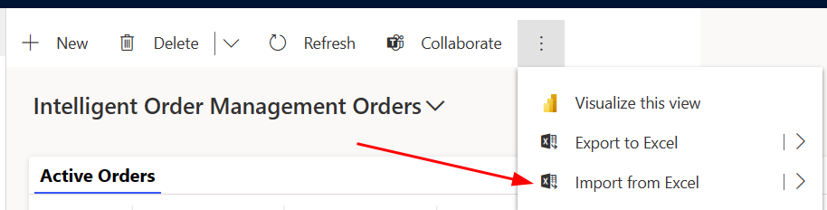
This will require that you have the data in a mapping that Intelligent Order Management can understand. There are simple mapping capabilities, but it is recommended that you follow the same field definitions that Intelligent Order Management uses.

Mapping
When integrating with external systems, you will often need to use Mappings to determine what external field and value maps to which record within Intelligent Order Management.
When activating a Provider, you will set its Mapping Group. Any transformations used by that Provider will lookup a mapping that is set for that Mapping Group. This allows you to have multiple mapping groups and different mappings per provider.
In this example, if the message coming from the external system has a field of customer_email with the value bennettray@microsoft.com, then the Account in Intelligent Order Management "Microsoft Internal" would be used.
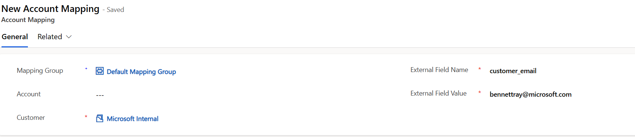
For information on what Mappings are available see Internal external ID mapping | Microsoft Learn
For a transformation using the following mapping, this is what you might need to setup with Intelligent Order Management
shared ImportMappingKey = [
account = {
[
ExternalRecordKey = [customer_id = Text.From(Source[order][customer][id])],
SelectedFields = {"accountid"}
]
},
pricelevel = {
[
ExternalRecordKey = [ProviderName = "Shopify"],
SelectedFields = {"pricelevelid"}
]
},
product = List.Distinct(List.Transform(Source[order][line_items], each
[
ExternalRecordKey = [productid = Number.ToText(_[product_id])],
SelectedFields = {"productid"}
])),
uom = {
[
ExternalRecordKey = [unit = "each"],
SelectedFields = {"uomid"}
]
}
];
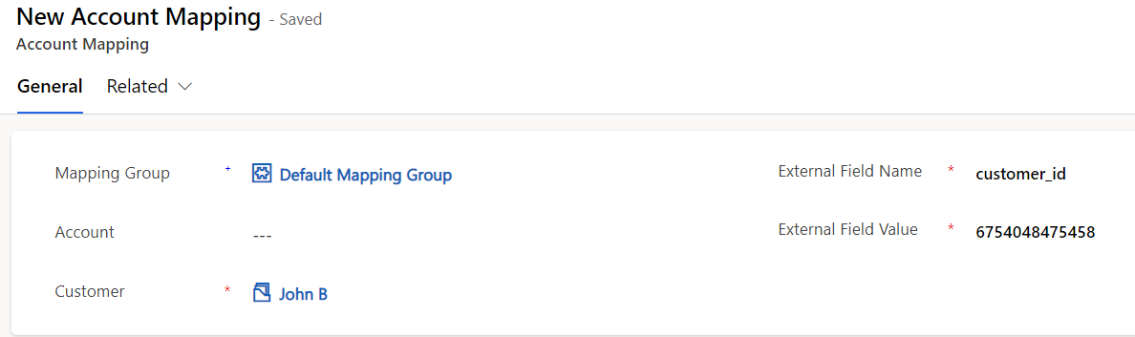
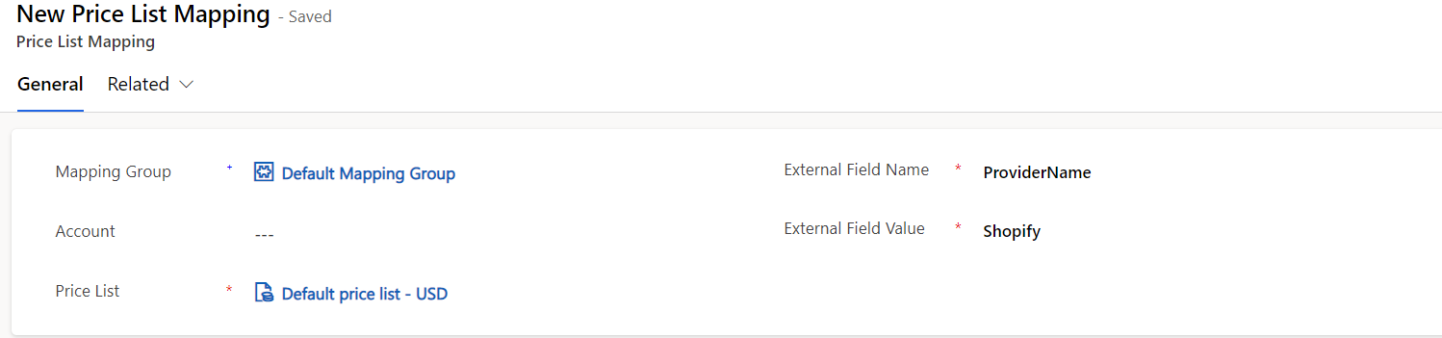
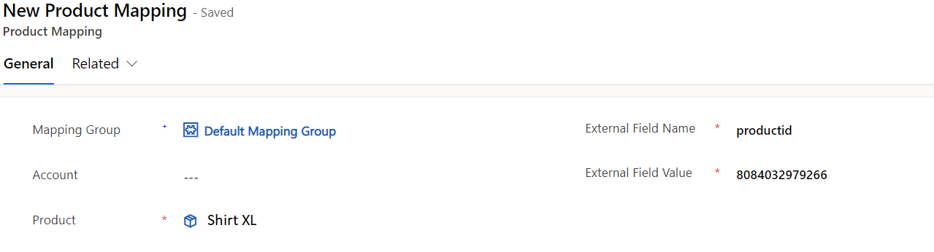
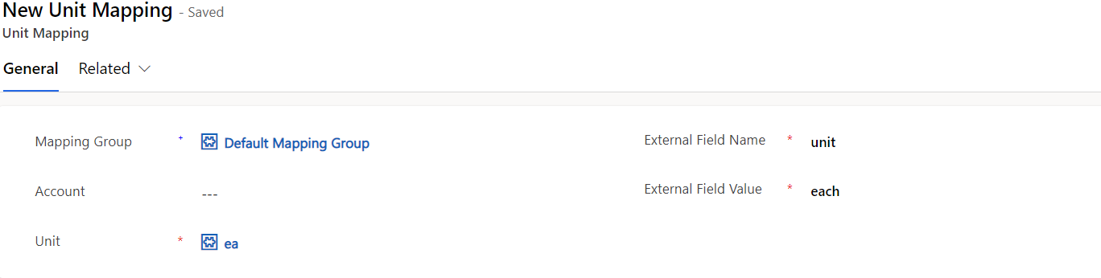

Integrating with Supply Chain Management
If you are using Supply Chain Management (SCM) there are additional configurations for integrating Purchase Orders and Transfer Orders
Integrate Supply Chain Management procurement with Intelligent Order Management | Microsoft Learn
Integrate Supply Chain Management transfer orders with Intelligent Order Management | Microsoft Learn

Setting Up your Providers
Using the list of defined or custom providers at the start of this document, you will need to activate these providers in your system. Activation allows you to install instances of those providers that define how to connect (credentials, tokens, etc), what parameters they use, and what transformations they use. Use the following guide to setup your provider(s) Work with providers | Microsoft Learn
NOTE: some providers only allow for 1 instance to be activated
You can use the following guides for setting up specific provider(s):
Set up Orderful provider | Microsoft Learn
Set up BigCommerce provider | Microsoft Learn
Set up Avalara provider | Microsoft Learn
Set up ShipStation provider | Microsoft Learn
Set up Flexe provider | Microsoft Learn
Set up the Fulfillment and Returns Optimization provider | Microsoft Learn
Set up Inventory Visibility provider | Microsoft Learn
Set up the Dynamics 365 Finance + Operations provider | Microsoft Learn
Set up Uber Freight provider | Microsoft Learn
Set up Adobe Commerce provider | Microsoft Learn
Set up the FedEx provider | Microsoft Learn

You can also customize out of the box providers to suit your needs Customize an out-of-box provider | Microsoft Learn – see the Development section below

Setting Up your Orchestration Journey(s)

Creating Policies/Rules
There are 2 types of Policies that can be used within Intelligent Order Management
- Filter Policy – these policies are used to filter a set of records that the Orchestration step will apply to. For example, if the orchestration is only supposed to apply to orders from Company = USMF, then a Filter policy can be used to restrict that step to only process orders that are within that Company. NOTE: this filter must be applied on every step that needs that filter applied. An orchestration step is triggered for every business event regardless of where it is raised.
- Execution Policy – these policies are used to test data against a set of rules, and fail if those conditions are not met. Additionally, you can use Actions to set data if the rule was successful. This type of policy might be used to set the Fulfillment Warehouse to Annapolis if the Quantity is less than 100, or to Seattle if greater than or equal to 100
See Policies and rules | Microsoft Learn for more information on policies and rules.

Creating Orchestration Journey
You will create an orchestration journey to manage how each of your entities (orders, etc.) journey through the system. Currently there are 4 journey types you can create
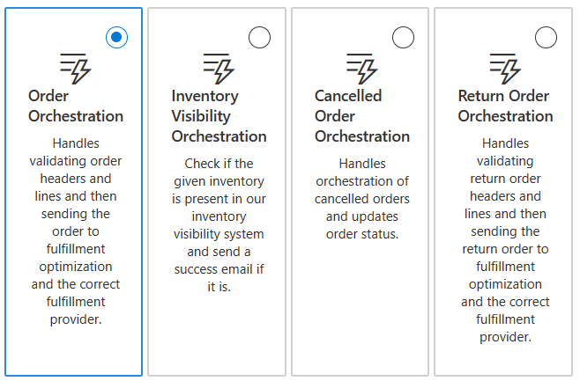
NOTE: future support will be added for more journey types, or possibly even a general orchestration for any entity.
Now you will create your Flow by using the + button to add steps.
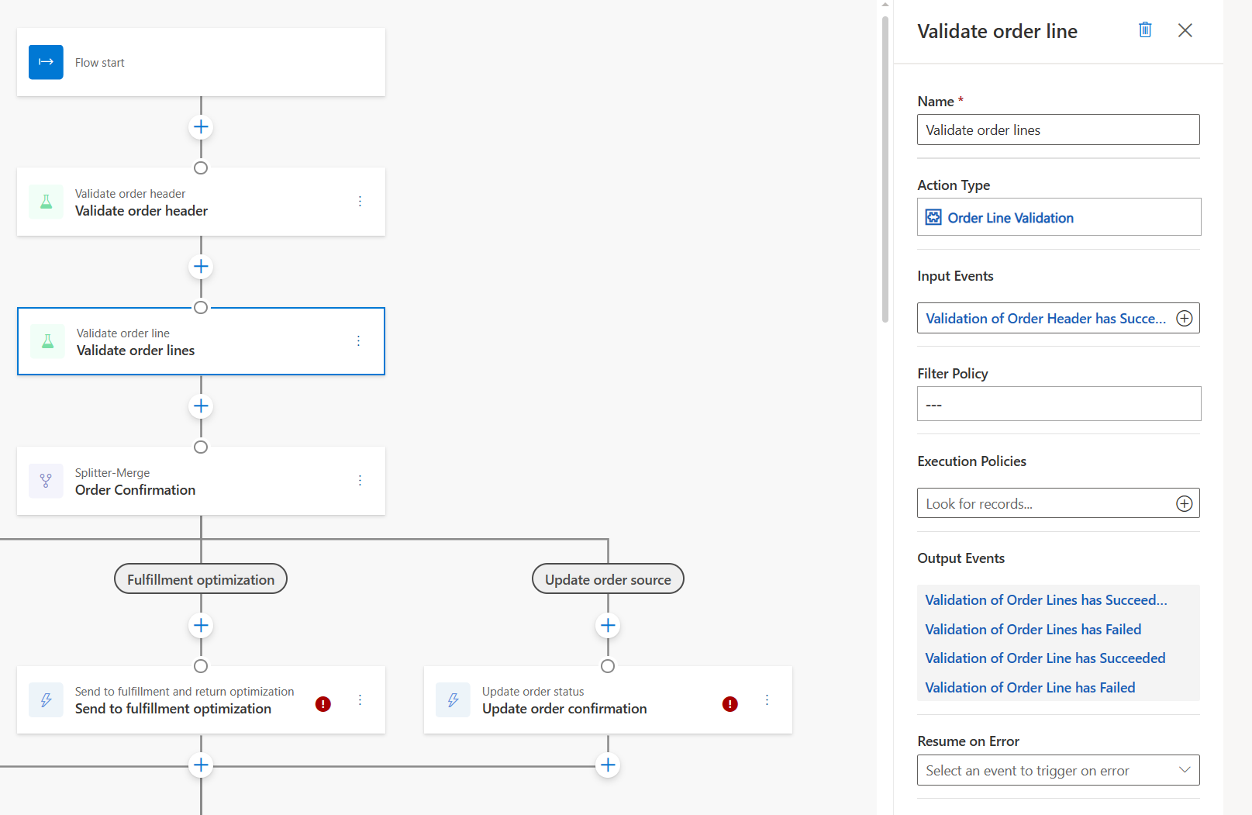
The basic concepts of creating an orchestration journey are as follows
- Click on the + to add a Step
- Select the Action you want to take. This list is a hardcoded set of actions that are known to be used for that Journey Type. You can also use Custom and use an Execution Policy or a custom Action Type. Using one of the built in steps only prepopulates some needed information.
- Give your Step a name that is descriptive to what you are trying to accomplish
- Select an Action Type. The Action Type determines what Business Events are raised when the step is Successful or Failed.
- Select your Input Events that will trigger this step. NOTE: any business event with this name that is raise in the system will trigger this step regardless of where it is triggered, even within another orchestration journey. You need to be careful to setup your flows to only raise events knowing where they will be triggered, or to use Filter Policies to restrict them.
- If you are calling a Provider Action such as Calculate Tax, select the Provider Action to call here. This is an optional field as you may just be using an Execution Policy. Note: these provider actions are for Installed/Published providers. You must enable a provider first. If the provider is de-activated you will be required to reselect this field when publishing.
- If you are using an Execution Policy, select it here. You can have multiple execution policies.
- If you are using a Filter Policy, select the policy that applies here. Similar to above, this needs to be an active published policy.
- You will see the Output Business Events that are raised on Success or Failure. Use these to determine what steps are defined next to handle the flow.
- If you set a Resume on Error, when the Reprocess button is clicked on an entity such as an Order, if the Orchestration failed on this step, this determines where to restart the journey when that button is clicked
For more information see Create orchestration flows | Microsoft Learn

Orchestration Guide

How to Create a Fulfillment Order
In order to create a fulfillment order, you will need to either manually assign a source, and send a fulfillment process request, or configure Fulfillment and Return Optimization and let it determine the best fulfillment source.
NOTE: Fulfillment requests are batched in order to handle order merging. It can take up to 5 minutes to see the Fulfillment Order. If you have not seen the Fulfillment Order after 5 minutes, you can see if the job has failed by checking Dataverse Table Event Management Job Queue and looking at the Status of the Fulfillment Job. Errors are logged in the Timeline which is a feature that must be enabled.
To manually set the source, you may want to use a combination of a Filter Policy and an Execution Policy. For example, if you want Sales Orders that come from Washington to use a specific Warehouse, you could create a filter policy checking the State. You can use a splitter to have multiple filter policies. The execution policy would set the Fulfillment Source.
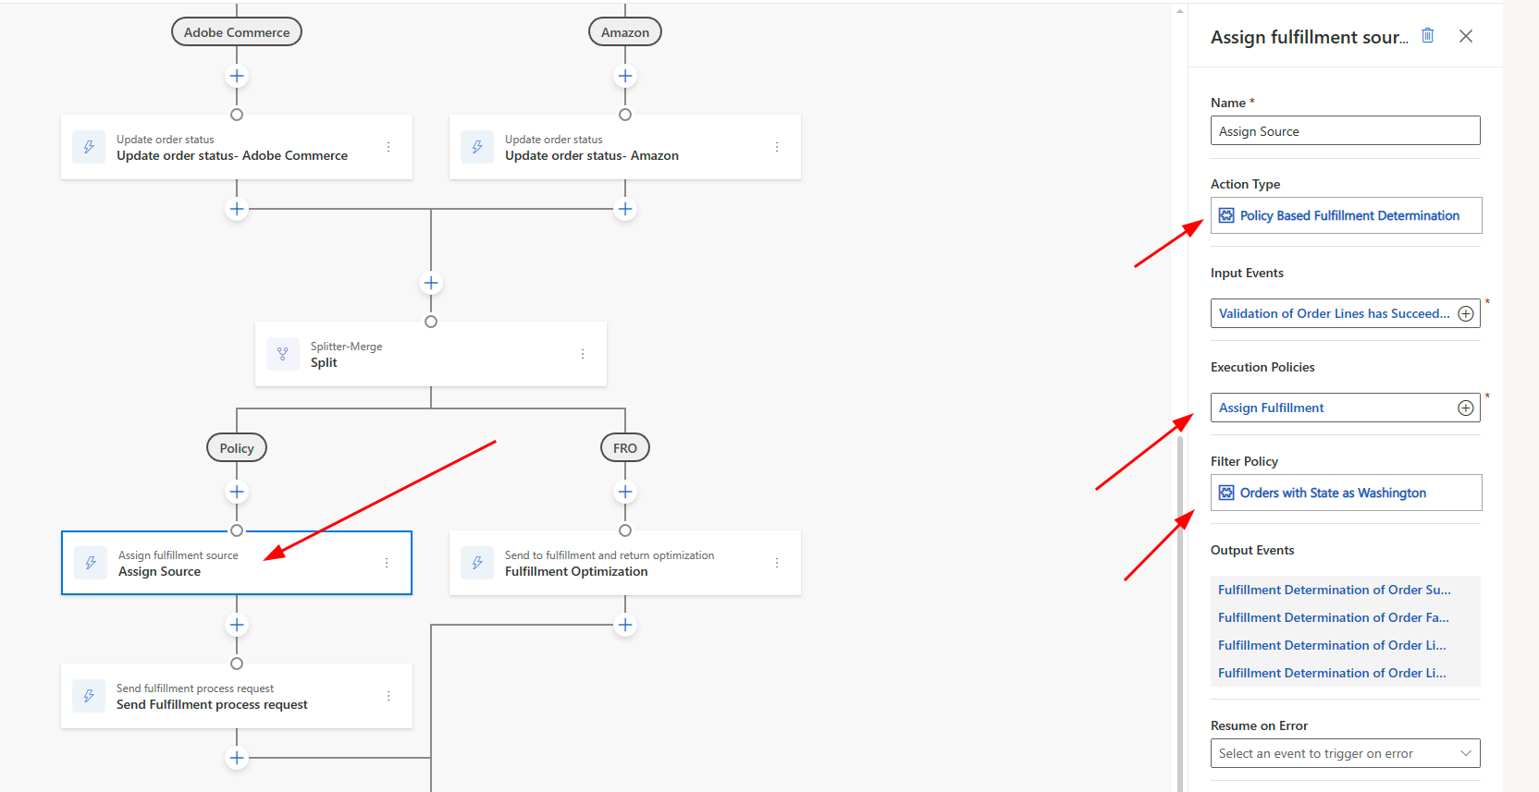
Once you have assigned the source, you can send a fulfillment process request
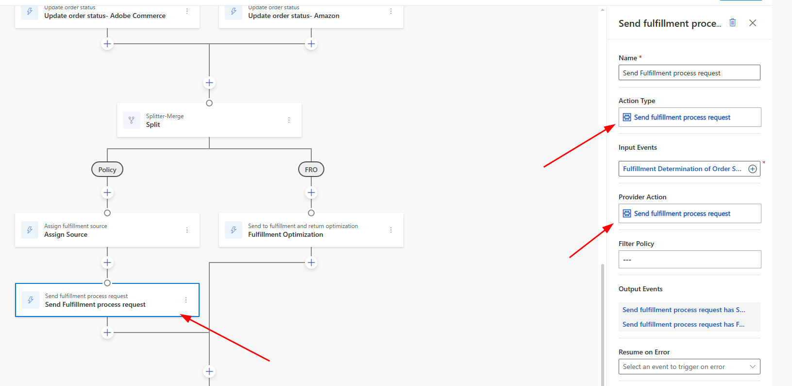
Note: Fulfillment cannot be used for Write-In products. Write-in products are intended to be used as an indicator to create a Product, then a Purchase Order and receiving the inventory before orchestrating the Sales Order.

Development
Please review the partner documentation and video on how to build providers Microsoft Dynamics 365 Intelligent Order Management Custom Provider overview
Intelligent Order Management is an application that is built on Power Platform and Dataverse using many of the built-in capabilities. You can customize and extend Intelligent Order Management like any other Power App Extensibility | Microsoft Learn
Familiarize yourself with the Architecture Architecture overview | Microsoft Learn

Custom Connector
A custom connector can be used to define an API that can be used directly in your Power Automate flows. These custom connectors define how to authenticate, and how to communicate with an external API. They are easy to build using OpenAPI or Postman.
These custom connectors are a part of Power Platform. You can see more about development of these here Custom connectors overview | Microsoft Learn
Additionally there are open source connectors hosted by first party and third party resources that may already have a connector implemented microsoft/PowerPlatformConnectors: This is a repository for Microsoft Power Automate, Power Apps, and Azure Logic Apps connectors (github.com)

Custom Provider – Intake
You can create a custom provider to handle intake of entities such as an Order. For example, you might want to get orders from a new Ecommerce website (such as Shopify and BigCommerce). It is first recommended to create a Custom Connector so that you have a tightly coupled connection to the API for retrieving orders.
Order intake is handled either by Polling (using a recurrence to connect and retrieve orders) or a callback where the external system calls into Intelligent Order Management. You will usually need to pass a checkpoint such as a token or a timestamp to only get New/Updated Orders from the external system. This implementation varies depending on the external provider.
If you are using a callback, see how to register a webhook as the URL for this API changes each time it is deployed Use a webhook as a trigger for Azure Logic Apps and Power Automate | Microsoft Learn
For more information on developing an Intake Provider, see the Partner training video above, or go through the Quick start lab for intake provider Create intake provider | Microsoft Learn

Custom Provider – Action
Developing a Provider Action allows you to call that action from within your Orchestration Journey. For example, you may want to update the Status of an order with the external provider after it has been shipped. Where/when you call out to your Shipment provider in your journey may change, so you might want to have an Orchestration Step that is triggered when Shipment is successful.
For more details on building a Provider Action, see the Quick start lab Create fulfillment provider | Microsoft Learn

Custom Provider – Other
Intelligent Order Management provides capabilities for Intake and Actions, but you can build Child Flows that can be reused as part of your other Flows and use those within your Provider Definition Logic Definition.
Additionally, you can build any type of Power Automate flow that can trigger off from events such as:
- A message being placed in an Azure Service Bus Queue/Topic
- A file being placed on an FTP server
- A record being Added/Updated/Deleted in Dataverse
This will allow you to integrate with legacy or systems not using a traditional REST API.

Supporting Child Flows
Intelligent Order Management has a set of Flows that can be called using the Child Flow Power Automate step. These flows are used to simplify the creation of providers, and to call internal functionality. A list of this flows are published at Dynamics 365 Intelligent Order Management Power Automate flows | Microsoft Learn

State Framework Considerations
Out of the box entities such as an Order, Order Product, Fulfillment Order, etc. are configured as part of the State Framework. When a Business Event is raised, a check is done to see if there is an allowed transition from the current State Definition to the Target State Definition. If the transition is not defined, an error is thrown.
You may want to customize these State Definitions and Transitions. To accomplish this, review State framework architecture | Microsoft Learn
You will be unable to customize the out of the box State/State Reason/Transitions as we rely on these as part of the product such as Fulfillment Optimization. You can add new States and Transitions as needed.
NOTE: The only method at this time to extend these is to navigate to the tables in the above documentation in Dataverse and using the Edit > Edit in Excel button at the top.

Application Lifecycle Management
Application Lifecycle Management allows you to track objects within a Solution in Power Platform, and export that solution to move it across to other environments.
Intelligent Order Management entities are tracked within Tables and you can export the data in these tables to move to another environment.
For more information on what tables are needed see Application lifecycle management for Dynamics 365 Intelligent Order Management | Microsoft Learn
Note: You can use the Power Platform Build Tools to automate export and import of that solution between environments as part of an Azure Pipeline Build tool tasks - Power Platform | Microsoft Learn

Upgrading
Intelligent Order Management makes updates regularly through Power Platform Admin Center. You can see if any updates are available by navigating to your environment and opening installed Dynamics 365 Apps. If an update is available you will be prompted to update to the new version.

Considerations for Upgrading
After upgrading, new versions of Intelligent Order Management may introduce new flows or change the behavior of the backend flows.

Steps after upgrade
It is recommended that you unpublish all orchestrations, policies/rules and active providers. After unpublishing, you will need to perform the following steps
- Activate your providers
- Publish your policies/rules
- Modify your Orchestration Journeys – the provider action will need to be removed and relinked to the new instance
- Publish your Journey

Issues with Deployment (ALM)
After upgrading, if you are moving your solution from another environment, you may hit an issue where fields are no longer present within the new environment. When fields are no longer needed, Intelligent Order Management does not delete the fields or data on upgrade on the source environment. That means there will be a reference to those fields in your solution. When moving this solution to a new environment that does not have these fields, you will get an error. Remove those fields from you source environment if they are no longer needed, or remove them from your solution. Alternatively, create those fields in the target environment.

How to Get Support
The best way of getting support for Intelligent Order Management is by using Power Platform Admin Center
- Navigate to Power Platform admin center (microsoft.com)
- Click "Help + support" on the left sidebar
- Click + New support request at the top of the page
- Follow the steps to create a support ticket

